Horan, Andrew (mainly from Linked In)
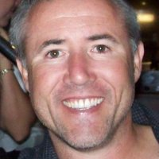

Karratha Senior High School Year 12 1981 – 85.

Graduate from Dwellingup cadet school/South West Institute of Technology, Bunbury Cert IV, Conservation & Land Management 1987 – 88. South West Institute of Technology Cert IV, Small Business Management 2007 – 09. Worked for Department of CALM 1989 - 2001. General Manager, Bunbury Dolphin Discovery Centre May 2001 – March 2008 in Bunbury. Business Manager, Smith Constructions Bunbury March 2008 – April 2010 in Bunbury. CEO Bunbury Chamber of Commerce & Industries April 2010 – October 2012 in Bunbury. Commercial Property Sales and Leasing and Business Broking at Southern Districts Estate Agency - The Professionals October 2012 – .

President Bunbury & Districts Little Athletics Centre March 2012 – . Year 11/12 Coach Harvey Brunswick Leschenault Junior Football Club January 2012 – .

